Media Relations Information for 10/02/2013
Public Relations Officer – Sgt. John Krueger
Office: 281-842-3161

La Porte Police host
another successful “National Night Out”
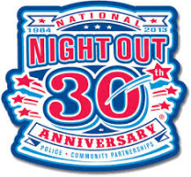

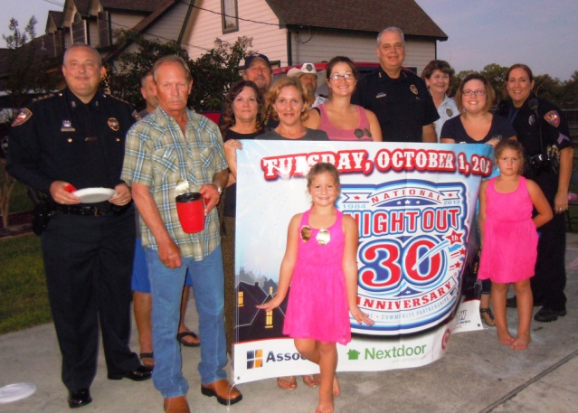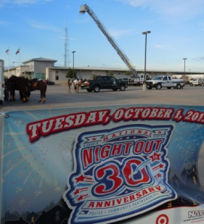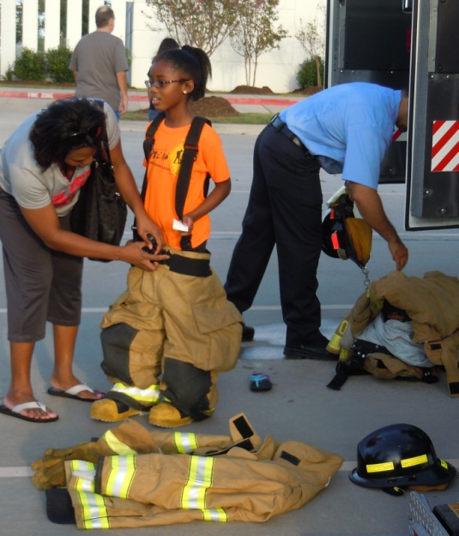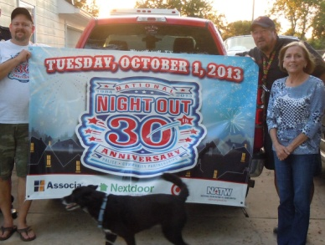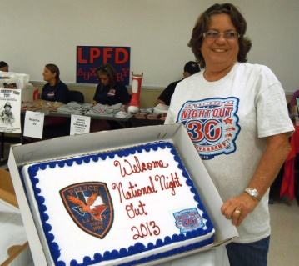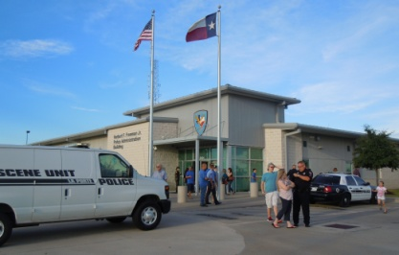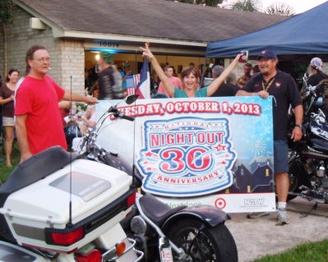
Various Neighborhood gatherings and a Police Open House were but a few of the event activities

On Tuesday October 1st, the citizens of La Porte jointed members of the police, fire, and EMS Department in celebrating National Night Out. As in previous years, the occasion was highlighted by the Police Department’s annual open house. However, several neighborhood gatherings were also held throughout the community and were attended by personnel from the City’s Emergency Services as well as members of City Council.

This year’s residential National Night Out events in La Porte varied depending on the neighborhood. Some neighborhoods hosted block parties, complete with food and refreshments, while other community members planned their events in nearby parks, advertising it within HOA newsletters weeks before the event. Other residents simply gathered among centrally-located neighborhood homes and socialized as children played.

In addition to over 200 citizens attending such neighborhood-centered outreach efforts, nearly 500 citizens visited the Porte Department’s open house at the Herbert Freeman Police facility. Open house attractions included guided tours of the police department, courtesy of the police department’s dedicated Citizen Police Academy volunteer staff and Youth Explorer Post. Other displays and demonstrations were provided by emergency services personnel from throughout Harris County, and also included members form LPPD’s Communications Division, Crime Victim’s Services, Bomb Squad, SWAT, DARE Program, Bicycle Patrol Unit, Animal Control, Office of Emergency Management, Fire Department, Emergency Medical Services, and the La Porte Municipal Court. Furthermore, staff representatives from Beacon, Shell, and JSC Federal Credit Unions, as well as area State Farm Insurance represented local business involvement. Representing area support units were local Civil Air Patrol members and the La Porte Fire Department’s ladies auxiliary. Food and refreshments were graciously provided by the La Porte Police Officer’s Association and Lil Jack’s Moonwalks offered recreational activities for the attendees at the police facility, free of charge.

National Night Out gives residents an opportunity to intermingle in a setting close to home, and showcases another example of how the La Porte Police Department strives to foster positive relationships and promote safer neighborhoods. For more information on the department’s involvement in their community, contact LPPD’s Support Services Division at 281-842-3183.

