Media Relations Information for 03/10/2014
Public Relations Officer – Sgt. John Krueger
Office: 281-842-3161

La Porte Police Support Service members help community recognize the risks of impaired driving

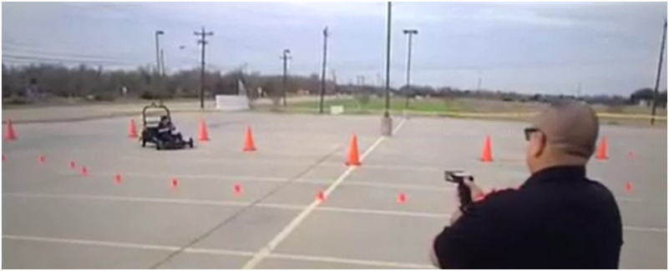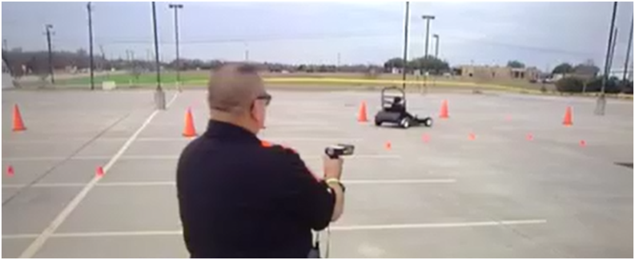

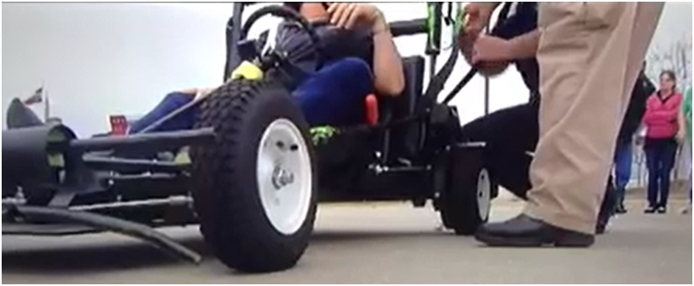
Officers Roger Gonzalez and Jeff Tippit teach participants in the SIDNE program learn how difficult it can be to manipulate a motor vehicle while impaired

On March 8th, 2014, area residents got a first-hand look at how truly difficult it is for an impaired driver to operate a vehicle safely. The event, sponsored by La Porte Police Department’s Support Services Division, utilized a go-kart style motorized device specially designed for DWI/DUI education. Participants in the event were introduced to a variety of educational experiences shown to open the eyes of those who do not have a full appreciation of the negative effects which alcohol and drugs can have on a person attempting to drive a motor vehicle.

The primary device used, known as the Simulated Impaired Driving Experience (SIDNE), was purchased by the Police Department last year through a generous grant from the Albemarle foundation, and serves as an ongoing joint educational venture hosted through the City’s Municipal Court and Police Department. The SIDNE car is a battery-powered vehicle that simulates the effects of distraction and impairment from alcohol and other drugs on a motorist’s driving skills. Assisting in the production of the event were members of La Porte Police Department’s Citizen’s Police Academy Volunteer group, as well as members of the La Porte Police Youth Explorers.

The SIDNE program has been shown, in La Porte and other comminutes throughout the nation, to deliver engaging and hands-on lessons about the misuse and abuse of alcohol and other drugs and the dangers of distracted driving. The program is hailed as a significant educational experience, and due to positive response LPPD will host additional hands-on public demonstrations of the SIDNE ANTI-DWI Program at the Police Department facility in the near future. For any questions regarding the City’s use of the Simulated Impaired Driving Experience, contact the Support Services Division at 281-842-3174 or 281-842-3183.

