Media Relations Information for 06/11/2014
Public Relations Officer – Sgt. John Krueger
Office: 281-842-3161

Anti-Bulling and Youth decision-making program hosted by LPPD

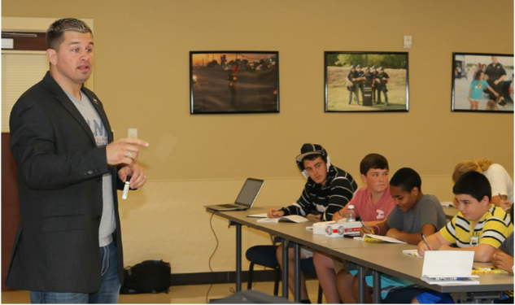
MLMP founder Daniel Puder inspires teens

On the morning of June 11th, the La Porte Police Department (LPPD) welcomed Daniel Puder and nearly 20 local teens for an advanced look into concepts on maturity, personal growth techniques, and life choice training. Puder is the founder and primary spokesperson for the My Life My Power (MLMP) program. The MLMP program is an anti-bullying and self-confidence building curriculum specifically targeted at those who face one of the most difficult transitional periods of life – teenagers.

Joining Puder were members of LPPD’s Support Service staff, to include the agency’s School Resource Officers (SRO) who are assigned to various LPISD campuses across the district. The teens in attendance, primarily members of LPPD’s Youth Explorer program, represented local youth from various neighborhoods and schools throughout the city. Those in the Explorer program have already started the journey toward maturity, having also discovered another avenue to connect with their local police department. The Explorers are made up of teens 13-18 who are shown various components within the Law Enforcement profession. Once in the program, they work side by side with police officers during various community programs and events.

Puder, an undefeated mixed martial arts fighter and former WWE Tough Enough Champion, founded MLMP in 2010 as a personal endeavor to curb bullying and promote a better level of decision-making among youth. Before rising to professional athlete, Puder struggled with being overweight as a teen and being enrolled in selected special education classes, which caused him to be an easy target for bullying. Upon reaching adulthood, he began to hear of kids who were committing suicide from being bullied, and felt a personal connection to the issue, knowing that something needed to be done to change the mindset of our youth. Therefore, rather than simply saying a few public words about this issue, Daniel was compelled to create a complete program geared toward youth, and implemented the system in schools and after-school programs to prevent more tragedies from happening.

The MLMP program takes a positive and proactive approach to challenges that students face by using motivational interviewing in which instructors ask the right questions, leading teens toward determining the best outcome for their lives. The core vision of MLMP is to genuinely empower youth and young adults toward having the intrinsic motivation to achieve success. While MLMP was founded with an emphasis on anti-bullying, the program also addresses several other areas in which teens struggle, such as Suicide/Self-Mutilation, Dropouts/Truancy, Drug and Alcohol Abuse, Physical and Sexual Abuse, Eating Disorders, Teen Pregnancy, Gang Violence, Childhood Obesity, Homelessness, Financial Literacy, and Physical and Mental Disorders.

The presentation by Puder at the LPPD facility was a major success, as attendees expressed both enjoyment of the program and feelings of enhanced self-confidence. For more questions on the MLMP program, visit the website at www.mylifemypower.org. Or if someone you know is 13-18 years of age and is interested in learning more about LPPD’s Youth Explorer program, the website link is www.ci.la-porte.tx.us/gov/police/support/youth_explorer_program/default.asp. LPPD’s Officer Roger Gonzalez can also be reached at 281-842-3183 for more information.

