Media Relations Information for 06/25/2013
Public Relations Officer – Sgt. John Krueger
Office: 281-842-3161

La Porte Rotary Club Members Paint Their Heart Out

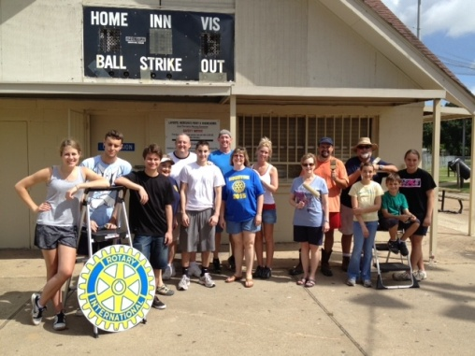
La Porte Rotary members enjoy June clean-up project

As part of their annual “Paint Your Heart Out” program, the La Porte Rotary Club set aside a June afternoon to paint the concession stand at the Farrington Ball Park, in the 3200 block of Farrington.

Members performed the service as part of their ongoing effort to help keep the image of, and quality of life within, our city high. Service members included, from left to right, Rotary Club International Exchange Student Ola Szczepanek (and friends), Crystal Redden, Ken Adcox (and son Andrew), Club President Ray Nolen (and wife Michelle), Brenda Thomson, Kathy Boehm, Victor Alvarado (and kids), and Jayo Washington.

The La Porte Rotary Club has been active in the community for over 70 years and whole-heartedly subscribes to the international motto of giving service above self. For more information on the La Porte Rotary, log onto their website at www.clubrunner.ca or stop by a Tuesday meeting at 12:00 p.m. on the grounds of St. John's Episcopal Church 815 S. Broadway @ Ave G La Porte, TX 77571

