Media Relations Information for 01/02/2013
Public Relations Officer – Sgt. John Krueger
Office: 281-842-3161

Motor vehicle burglars tracked down by La Porte Patrol officers

Around 4:00 a.m. on January 1st, La Porte officers responded to the 1400 block of Canyon Springs Road in reference to a Burglary of a Motor Vehicle offense that had just occured. Responding officers observed the suspects as they attempted to flee the area and a foot pursuit was initiated. Police were able to immediately capture one of the suspects, while the second suspect was able to initially evade capture. The outstanding suspect was subsequently identified through investigation and taken into custody a short time later. Both suspects were found in possession of stolen property and various burglary tools.

The suspects, both of La Porte, were charged with Burglary of Motor Vehicle and Evading Arrest. The Harris County District Attorney’s Office accepted charges against Austin Collom who will face Class A misdemeanor charges for the Burglary offense and a Class B misdemeanor charge for the Evading Arrest. The offenses carry a penalty ranges as high as a $4000 fine and up to a year in jail. The second suspect, however, was 16 years of age and a juvenile under state law. As such, his identity is not being released at this time and he was released that evening to his mother, upon directive of Juvenile Probation services.

The recovered property was evaluated by responding officers and various items were linked to two other area residents whose unlocked vehicles had also been entered by the pair. Because of the similarity of this event to many other area vehicle crimes, the La Porte Police Department is looking into the possibility that the two suspects may have been involved in other area crimes. They are also reminding residents to keep their vehicles locked at all times, park in well-lit areas, and remove valuables stored inside their vehicle from plain sight. Should you have additional information or tips relating to any criminal activity, please contact LPPD’s Criminal Investigation Division at 281-842-3173.

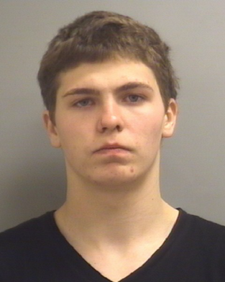

Juvenile Male
Involved

PHOTO WITHHELD
Austin Collom
12/06/1995

