Media Relations Information for 12/15/2012
Public Relations Officer – Sgt. John Krueger
Office: 281-842-3161

LPPD Patrol Officers Capture Yet Another Car Burglar: Unlocked Vehicles Still a Problem

Shortly after 1:00 a.m. on Sunday December 9th, an attentive La Porte Patrolman observed a male in his mid 20’s entering and exiting various residential driveways in the City’s Fairmont East subdivision. Given the time of day and guarded movements of the male, the patrolman quietly maneuvered around the area to monitor the suspicious person. While shifting positions, the patrolman then observed a set of open doors on an unattended vehicle within a residential driveway, and another nearby vehicle with its engine running while parked in a vacant residential driveway. The suspect eventually ran toward the nearby running vehicle and got inside. The patrolman quickly closed in and approached the vehicle, which was occupied by the male who had been roaming the neighborhood and a female passenger.

Additional LPPD officers responded to assist in the preliminary questioning, when a consensual search of the vehicle resulted in the recovery of hundreds of dollars of electronics which could not be accounted for by either of the vehicle occupants. Subsequent investigation determined that much of the property had been taken from vehicles in the area over the past several nights. Charges were later authorized by the Harris County District Attorney’s Office against the male, 25 year old Wilbert Sneed of La Porte, for the offense of Burglary of a Motor Vehicle. Sneed has since been linked to as many as 8 vehicle burglaries in the La Porte area, all of which were believed to be unlocked at the time of the offense.

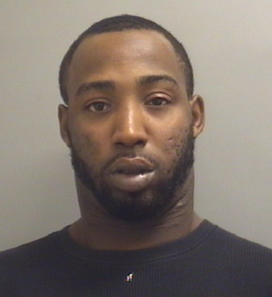
Wilbert Sneed
10/08/1987

