Media Relations Information for 12/31/2012
Public Relations Officer – Sgt. John Krueger
Office: 281-842-3161

LPPD, Citizen’s Police Academy Alumni, and other area service agencies spread holiday cheer to less fortunate children

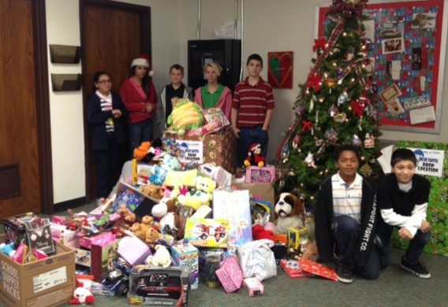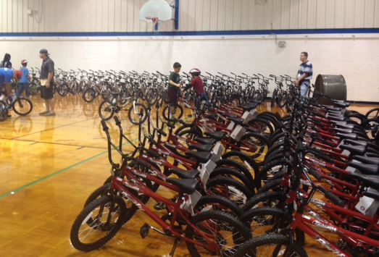
Blue Santa Drop-off point at Baker Middle School and Elves & More Bicycle distribution

While most people are busy engaging in the hustle and bustle of Christmas holiday shopping, the participants of La Porte’s Blue Santa Program take a different approach by starting early and engaging in various fundraising activities within the six-month period preceding the Christmas season.

The Blue Santa Program represents a collaborative effort between the La Porte Police Department, Citizens Police Academy Alumni Association (LPCPAAA), Municipal Police Officer’s Association, Municipal Court, Fire Department, and Independent School District. The Program’s primary mission is to provide toys and Christmas dinners for needy children and their families in the La Porte area, many of whom would not have the means to hold traditional Christmas festivities on their own.

As a result of the 2012 Blue Santa program, the joint La Porte organizations collected nearly 1000 new toys, including some 300 bicycles provided through the Elves & More Program, with the help of area Boys and Girls Club members. Any cash donations received were used to purchase additional toys, all of which were distributed to less fortunate families by La Porte’s Neighborhood Center and the City’s Jennie Riley Community Center. All in all, the program’s annual efforts touch the lives of numerous families every year, allowing hundreds of children to experience the joy of Christmas.

La Porte Police Department stresses that it is through local teamwork, such as the Blue Santa and Elves and More Programs, that all La Porte residents can make a difference in the lives of those who are less fortunate. For more information on any of La Porte Police Department’s community outreach initiatives, including the CPAAA, Blue Santa, and Elves & More Programs, please contact the Support Services Division at 281-842-3183.

