Media Relations Information for 04/22/2013
Public Relations Officer – Sgt. John Krueger
Office: 281-842-3161
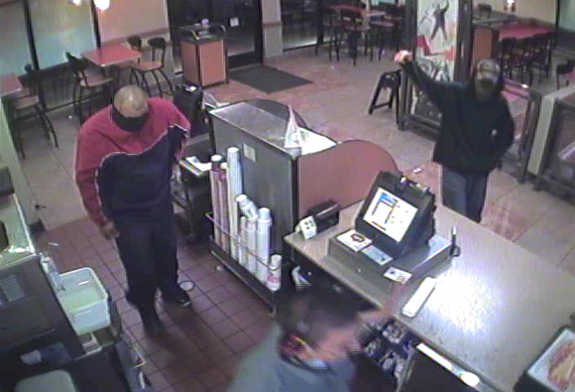
AGGRAVATED ROBBERY – La Porte

A few minutes after 11:00 pm on 4/19/2013, La Porte Police received a 911 call from a Jack in the Box restaurant within the 9600 block of Fairmont Parkway in reference to a robbery which had just occurred.
The reporting night manager advised that at approximately 11:03 p.m. two male subjects entered the business through the east-side door and started demanding money from the registers.

Suspect #1, believed to be a Hispanic male, was described as approximately 6`00"-6`02" weighing approximately 200-225lbs., wearing blue jeans and a red and blue windbreaker type jacket. Suspect #1 had what appeared to be a turtle neck shirt pulled above his nose to prevent his face from being seen.

Suspect #2 , also believed to be a Hispanic male, was described as approximately 5`09", weighing approximately 165-180lbs., and wearing dark clothing with an unknown type of material positioned above his nose, covering the majority of his face.

The Jack in the Box manager advised that the 1st suspect initially stood by the entrance of the front counter and proceeded to lift up the front of his shirt, displaying a silver semi-automatic handgun with black handle to restaurant employees. Subject #2 then walked behind the counter, grabbed the register, and attempted to pry it open with what appeared to be a screwdriver but was unsuccessful. The manager proceeded to empty the cash from the drive-thru register and placed the money into a paper bag. Suspect #1 then grabbed the bag from the manager, containing $236, and both subjects fled out the east side door in an unknown direction. Employees were unable to see if the subjects fled on foot or left in a vehicle.

LPPD Crime Scene technicians were called out to the restaurant and have examined the location thoroughly. La Porte Police are asking area residents if they recognize either of the suspects pictured to call investigators at 281-842-3173.

