Media Relations Information for 04/08/2013
Public Relations Officer – Sgt. John Krueger
Office: 281-842-3161

LP’s Trash Bash and historical cemetery clean-up prove successful

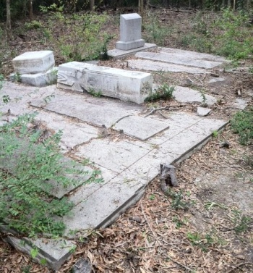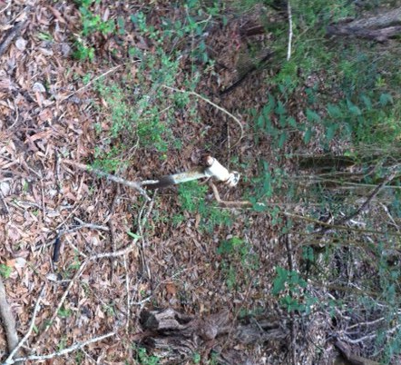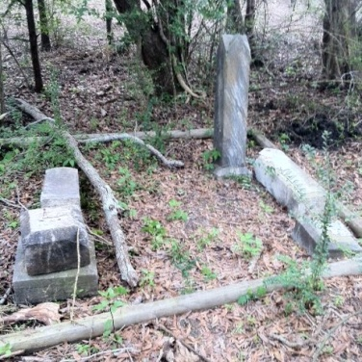

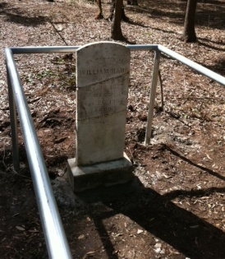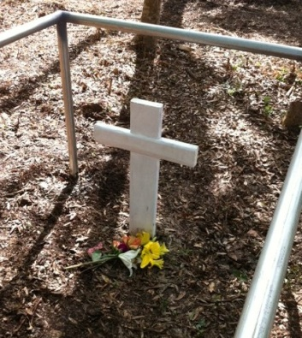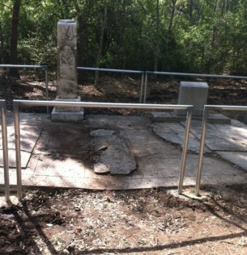
Before and After Photos of La Porte’s Cedarhurst Cemetery

Over 70 volunteers from the La Porte Bayshore community, along with various representatives from local government and industry, pitched in this past Saturday to make the City’s annual Trash Bash a success. In addition, this year welcomed an expansion to the event by way of a historical cemetery clean-up at the Cedarhurst Cemetery, and a hazardous waste drop-off at the City’s Equipment Services facility. In the end, the April 6th festivities proved extremely productive for beatifying and preserving the La Porte landscape.

Various La Porte public service entities and volunteer groups joined forces not only to clean up their community, but also to protect a frail La Porte historical cemetery which had remained relatively unknown to most area residents. The Cedarhurst Cemetery, the final place of rest for several of La Porte’s original residents, has been in dire need of restoration for decades. However, through the work of La Porte’s Masonic Lodge, Rotary Club, Lions Club, Citizens Police Academy Alumni Association, City government, and several local businesses, the site was cleared from the heavy brush, trees, and erosion that had overtaken the area.

The City of La Porte co-sponsored the event in an effort to add to their ongoing local beautification and preservation efforts. Cedarhurst was La Porte’s first burial site, established in 1901, but unfortunately had become a virtually unrecognized area with a significant amount of natural overgrowth and trash accumulation. However, thanks to the effort of the 70+ volunteers, the cemetery and many of La Porte’s local areas received a major springtime facelift.

The City of La Porte has intentions of holding another Trash Bash next year, however there are many opportunities in the meantime to volunteer for your community. For more information on such projects, please contact the City of La Porte Parks and Recreation Center at 281-470-7275 for more details.

